

**Design & Innovation Project (DIP)**

**Project Report**

**UAVIONICS Group B**

**Project Group: E023**

**Submitted by :**

**See-To Junwei (U1921517E) (Leader)**

**Tan Pin Che (U1522944C)**

**Loke Yee Wai, Ivan (U1922667F)**

**Alexander Pacer Sartin (U1922082K)**

**Shoon Zhen Yong (U1920283L)**

**Supervisor : Prof Chong Yong Kim**

**School of Electrical and Electronic Engineering**

**Academic Year 2021/22**

**Semester 1**

# **Acknowledgement**

We would like to express our gratitude towards Prof Chong Yong Kim, Prof Lim Meng Hiot and the project helpers for guiding and providing insightful support during our initial and research stages of our project.

Prof Chong Yong Kim is a responsible and reliable supervisor who gave us his honest opinions and guidance when we needed it. He always inquired and challenged us to enhance our creativity and critical thinking. Furthermore, we are sincerely grateful for his support in terms of the resources and ideas he has provided us which greatly assisted us in our research for our project.

With their help and support, the project was able to be successfully completed.

# 

# **Table of Contents**

(click to navigate)

1. Purpose / Project Objectives

2. Project Summary

3. Scope

3.1 Project Deliverables

3.2 Hardware Components

3.3 Autonomous Drone Flight

3.4 Integration of Functionalities

3.5 Creating simulated warehouse environment

3.6 Changes to Scope

4. Weekly Schedule

5. Project Costs

6. Outcome / Expected Outcomes

7. Reflection

7.1 Engineering Knowledge / Problem Analysis

7.2 Design / Development of Solutions

7.3 Individual and Team Work

7.4 Future Recommendations

7.5 Methodologies Applied

7.6 RACI Chart

8. Individual Contributions

9. References

# **1. Purpose / Project Objectives**

Wireless technology has brought about a technological development, the drone, which is a type of unmanned aerial vehicle (UAV). The drone’s great mobility and lightweight structure bring possibilities for many human-centric applications.

We wanted to explore building a compact drone and engineering it to solve real-world problems. Specifically, we focused on the drone’s potential applications in logistics. In modern storage networks, there’s an increasing tendency to spread inventory space outward. Stocks in large warehouses are usually piled up high, out of reach, or spread across a wide floor area. This exponentially increases the difficulty in taking inventory for a manual worker.

Intuitively, we came up with a general objective: **Reduce human labour needed for stocktaking.** In meeting this objective, overall quality of life is improved for logistics workers, as they can allocate time to more productive tasks, and the need to scale to heights to stock-take would be eliminated.

We found that the drone is a suitable device that meets our objective effectively.

Therefore, the end product of our *UAVonics* project is a drone capable of stocktaking autonomously inside warehouses where stocks are organised on shelves.

We aimed to achieve the final functionality of the drone by Week 13, and thus project development was split up into various phases. In each of these phases, each member specialised in duties like improving the drone’s reliability and developing the drone’s functions. This process will be detailed fully in later chapters.

# 

# **2. Project Summary**

We were given a 10cmx10cm drone based on the ESP-32 to develop our functionality. It is able to perform hands-free flight while being equipped with sensors to detect and transmit information.

By using a physical marker system called Aruco (written as ArUco), we are able to task the drone to fly a designated path within a warehouse. Secondly, using OpenCV libraries for image recognition, the drone can identify individual stocks using their QR codes. The information on coordinates and where each stock is stored is fed back to the program GUI, for the human operator. We managed to achieve this final functionality by the end of the project.

Near-object avoidance was a side function to improve the reliability of navigation by making the drone avoid crashing into any objects. We initially explored this but soon realised it was difficult to implement alongside the autonomous flight path, without interrupting it. This feature was eventually left out, but the reliability can still be ensured by operating the drone in a controlled environment with no moving hazards.

In summary, the drone was completed and tested in a simulated warehouse environment. This shows the drone can be deployed as a replacement for human workers for our specific task, stocktaking. Therefore it accomplishes our overall aim of reducing human labour used, leading to better quality-of-life for workers.

# 

# **3. Scope**

## **3.1 Project Deliverables**

Our project aims to deliver a program that is able to autonomously fly a drone while scanning for QR codes to produce a stock checklist.

We have broken down the task into these main deliverables:

1) Autonomous drone flight

2) QR Code detection and decoding

3) Integration of all parts into a single program

In addition to these goals, in the midst of our development process we realised we needed an environment to simulate the flight path in a warehouse and thus our last deliverable is:

4) Create a simulated warehouse environment

The deliverables will be worked on using the hardware provided by the school.

## **3.2 Hardware Components**

Below are the hardware components that will be utilised in building the 10cm x

10xcm drone.

1. Quadcopter Drone Body
2. ESP 32 Development Module
3. OVO 2540 Camera
4. IMU Sensor Module
5. Battery

### **3.2.1 Quadcopter Drone Body**

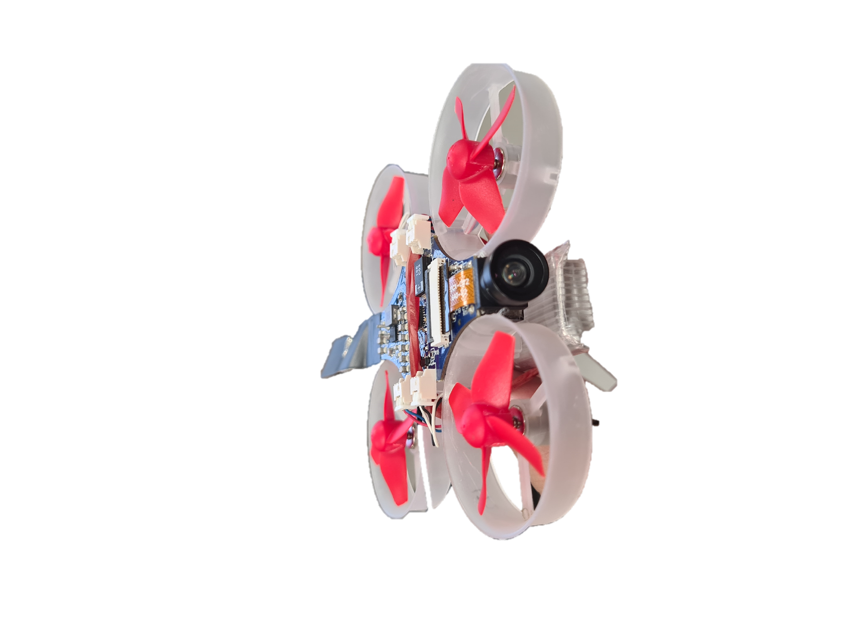

Figure 3-1: Quadcopter Body

The quadcopter body is a 10cm x 10cm small and lightweight base, with a custom circuit board (PCB) attached to the micro drone.

The general specifications of the quadcopter are as follows:

• Motor: 4x brushed motors

• Flight time: around 5 minutes

• Charge time: approx. 30 minutes (combined total of 6 batteries)

• Dimension: approx. 85 x 85 x 30 mm

• Net weight: 26 grammes

• Main processor: ESP32-S microcontroller

• Features: onboard Wi-Fi and Bluetooth, onboard camera, connector for external antenna

### **3.2.1 ESP-32 Microcontroller**

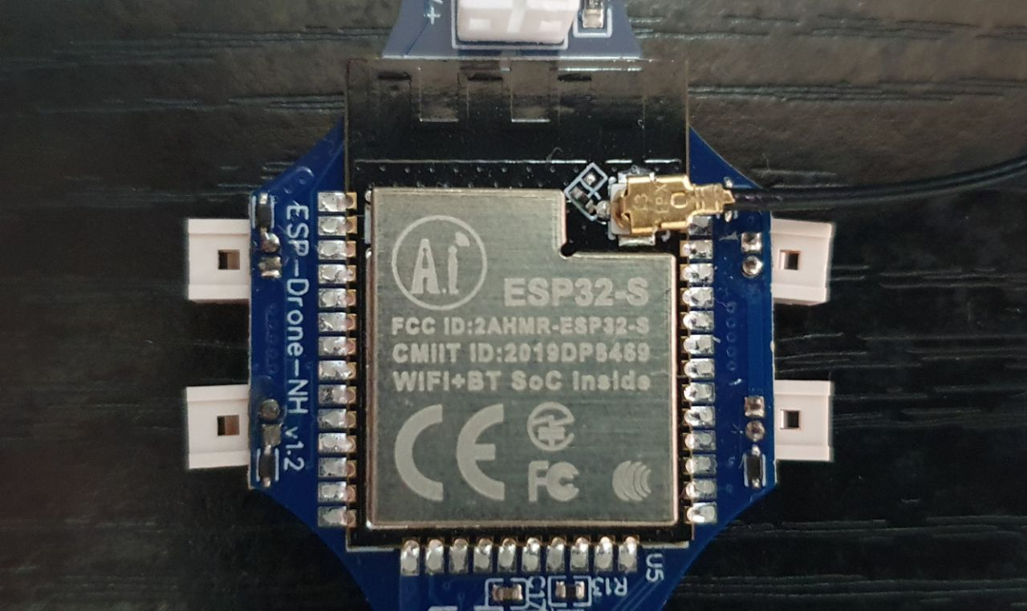

Figure 3-2: ESP-32S Microcontroller

A microcontroller is a compact integrated circuit used to perform specific operations in an embedded system. The ESP-32 Microcontroller in our project is a microcontroller that features Wifi and Bluetooth capabilities built in, it also has a high level of integration which increases its functionality and versatility to suit our needs in our project such as ROS communication.

Specifically, we will be using the ESP-32-S microcontroller from the ESP-32 family. The ESP-32-S microcontroller features a dual CPU, which would allow us to run separate tasks concurrently. This feature would allow us to perform tasks such as streaming the camera image from the drone and perform control loops on the drone (for stabilizing the drone) at the same time.

### **3.2.3 OVO 2640 Camera**

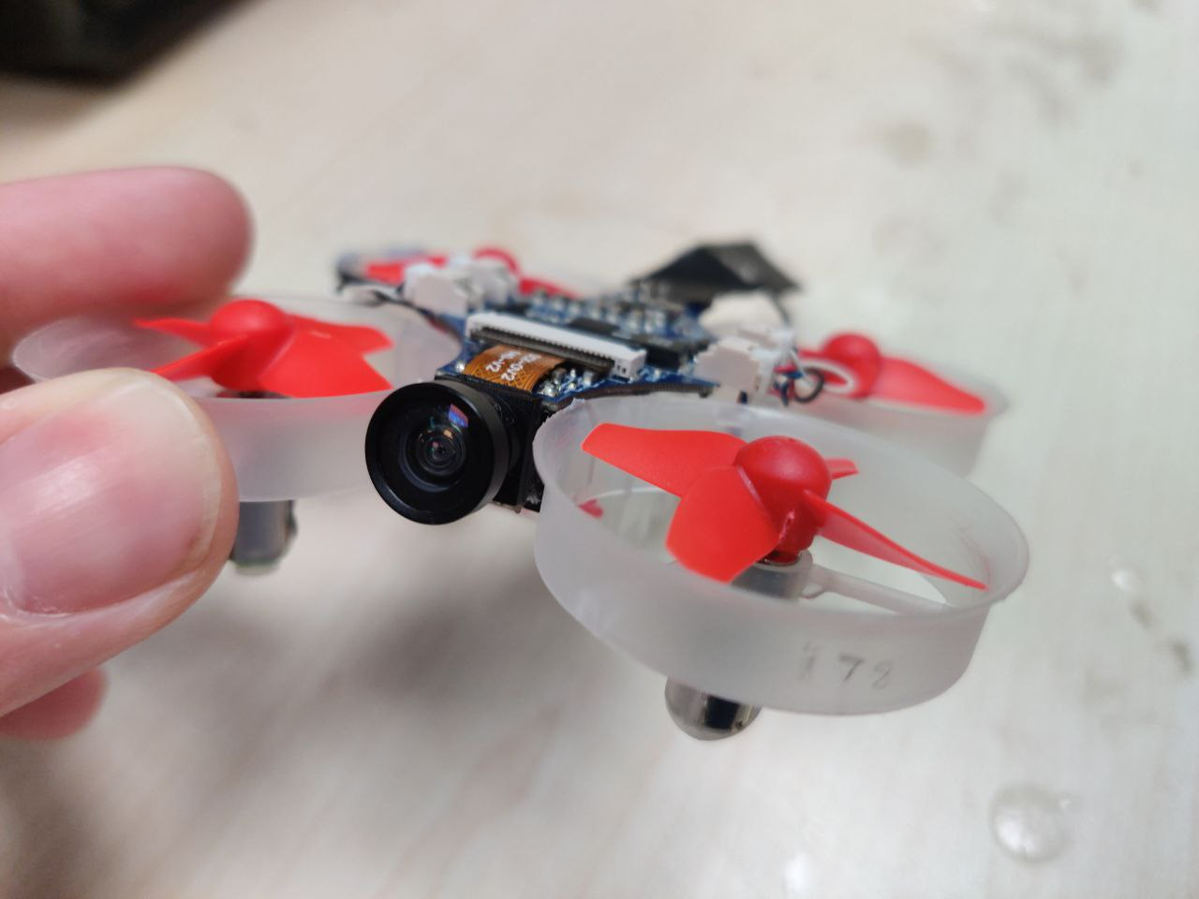

Figure 3-3: OVO 2640 Camera

The camera attached to the ESP-32 Microcontroller is an RGB camera, with its video stream accessible via Wi-Fi. Various additional image processing algorithms can be integrated through the Robot Operating System (ROS), allowing it to perform various tasks such as object detection and recognition.

### **3.2.4 IMU Sensor Module**

The Inertial Measurement Unit (IMU) has the main function of stabilizing the drone while it is in flight. The IMU consists of an accelerometer and gyroscope which measures linear and angular velocity respectively. The data that is received from this sensor is then used as parameters for the drone.

### **3.2.5 Battery**

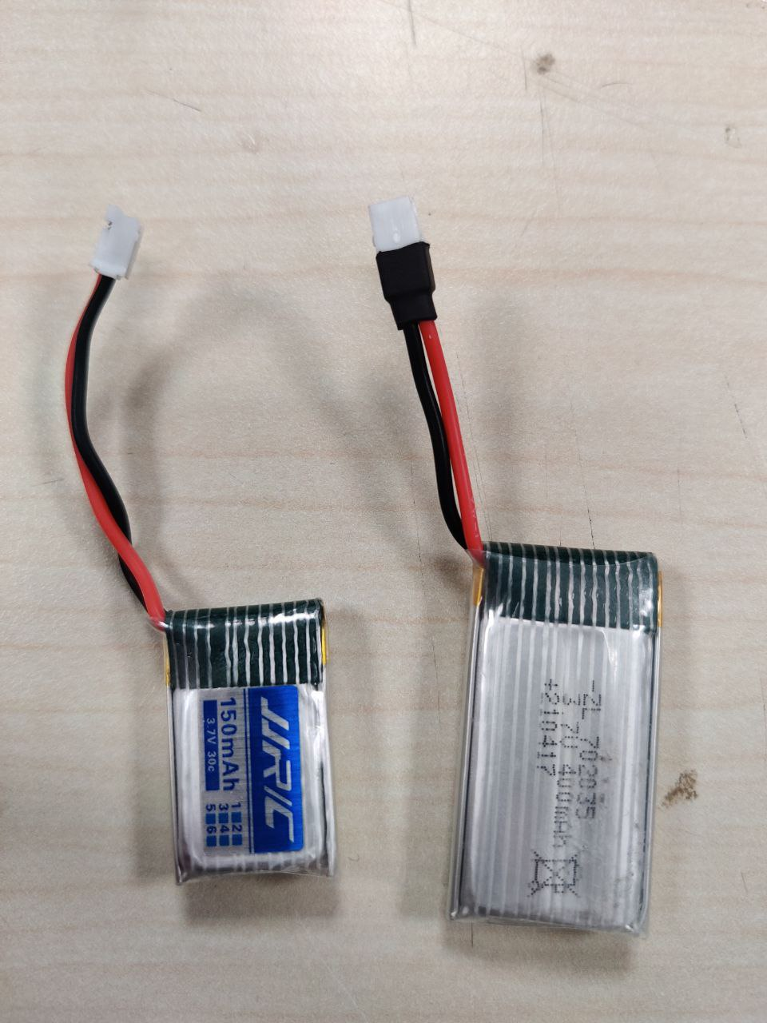

Figure 3-4: 400mAh (top) and 150 mAh (below)

We were initially provided with 6 Li-ion batteries, each providing 3.7V with a capacity of 150mAh, and only one would power the drone at a time. This translated to roughly 5 minutes of flight time before each battery would run out and need to be replaced. In order to circumvent this issue, we obtained a larger 400 mAh battery which gave us more than 10 minutes of flight time. It greatly improved flight time while adding a small amount of weight that the drone could still lift. This improvement ensured we could fly the drone around 2 rows of shelves much more reliably.

## **3.3 Autonomous Drone Flight**

Achieving Autonomous Drone Flight can be split into two steps:

1. Determining the drone’s current position and orientation as well as velocity
2. Sending commands to the drone to direct its movement

#### **Step 1: Determining the drone position and orientation**

For determining the drone’s current position and orientation we have decided to use the ArUco open source library [1]. By printing ArUco markers and pasting them within an area we are able to create a 3D visualisation map of our environment which we can then use to determine the drone position and orientation. As long as the drone is able to detect at least 2 ArUco markers, it will be able to accurately determine position relative to the ArUco markers within its view. This information coupled with the 3-D visualisation map of the environment allows us to accurately determine the position of the drone within our experimental area.

To create a 3D visualisation map of our simulated warehouse environment, we first placed ArUco Markers through the area.

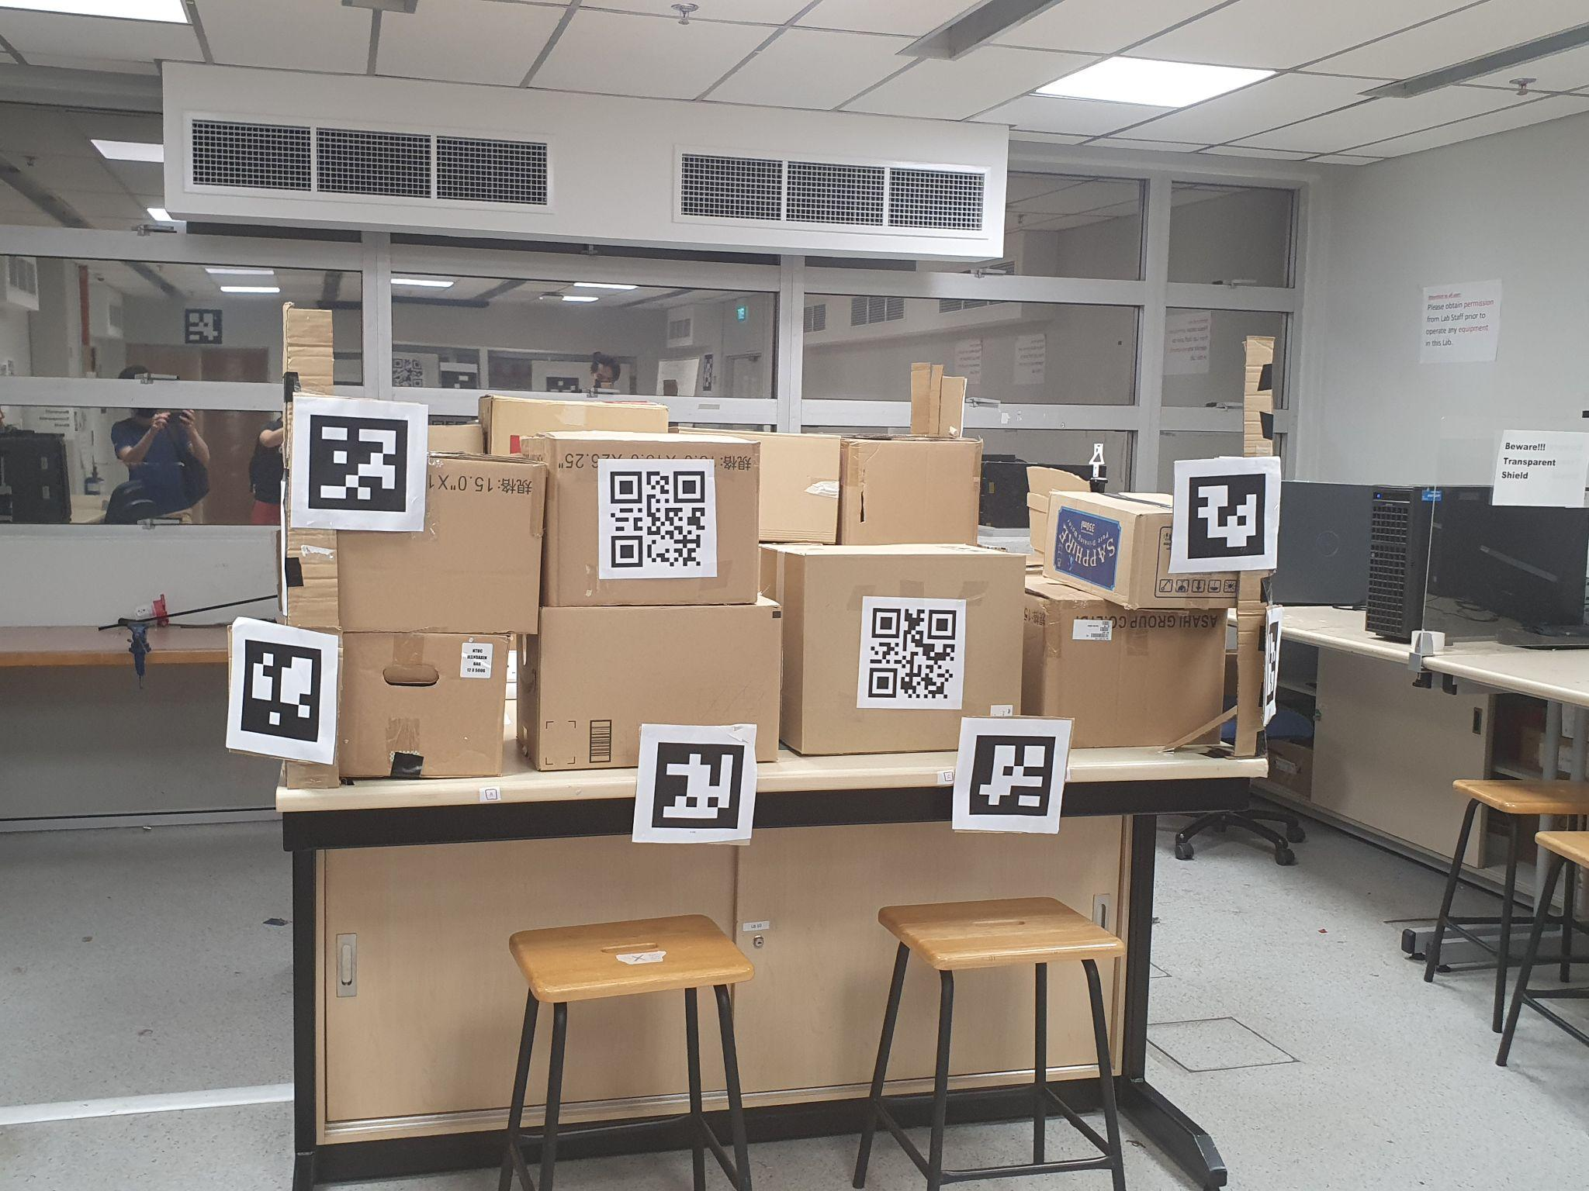

Figure 3-5: Simulated Warehouse Environment

After placing ArUco markers around our simulated warehouse, we map out the simulated warehouse using the Aruco MarkerMapper application, which is one of the tools in the ArUco library.

Figure 3-6: Aruco MarkerMapper application

To create a map, calibration of the phone’s camera must be done beforehand. For calibration, the exact aruco size in metres must be specified. Then, at least 5 images of the aruco marker with the indicated size will be required, from different angles and levels.

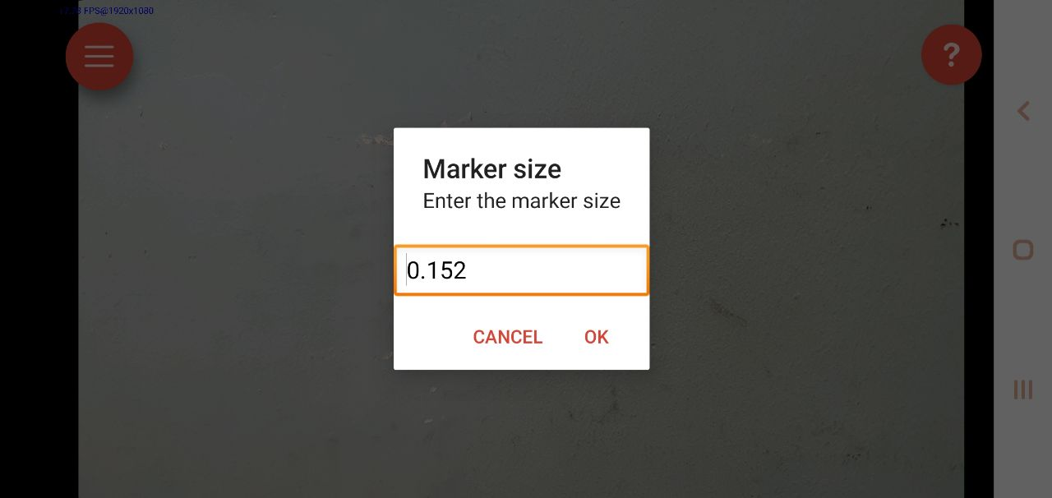

Figure 3-7: Marker size

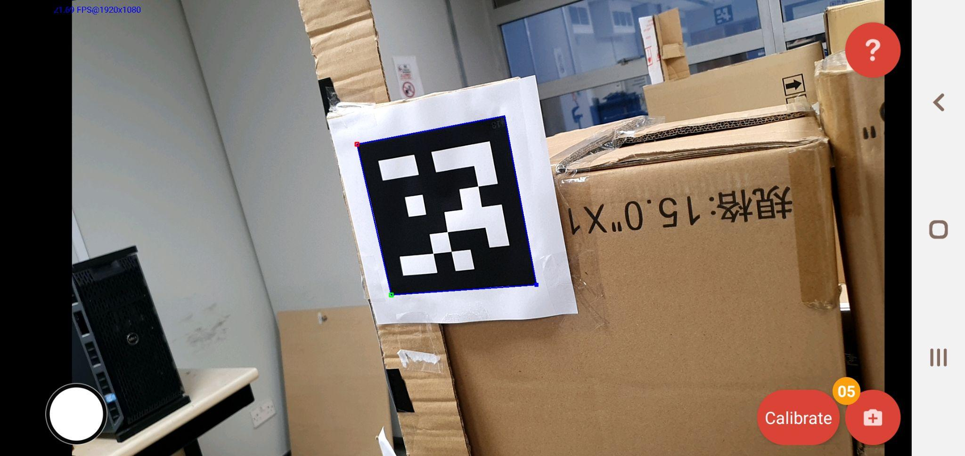

Figure: 3-8 Taking pictures of the ArUco Marker using the app

After calibrating the phone’s camera, we map the area by taking pictures of the aruco markers set up, along with the correct orientation of the room. The resulting process will result in the 3-D map data in a .yml file format.

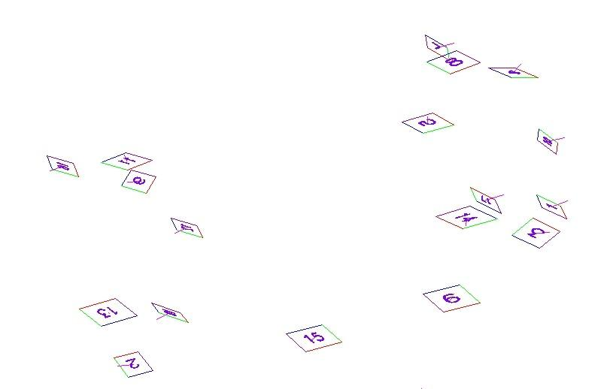

Figure: 3-9 Mapping of environment in Aruco Maker app

With the ArUco Markers setup, and the map data created, we can now accurately determine the position and orientation of our drone as long as it is able to detect 2 or more ArUco Markers.

#### **Step 2: Sending commands to the drone**

After determining the drone’s position, the next step is to direct the drone’s movements. Wireless communication with the drone is done through the *espdrone lib python* provided by the DIP team which also provided a ROS wrapper for the library called *espdrone_ros*.

### **3.3.1 ROS Implementation**

ROS is short for Robot Operating System and is an open-source, meta operating system for robot systems, and provides services that are very useful in our project such as message passing between processes, and package management. It can provide us the tools and libraries we need for obtaining, writing, and running code across multiple processors. Furthermore ROS has the advantage of allowing us to run and implement commands across different programming languages, such as C++ and Python. This provides us with the flexibility of writing C++ ros nodes and programs as through the ROS wrapper “espdrone_ros” any C++ ROS node we write will have access to the functions provided by the python library.

The espdrone_ros package provides many topics such as “*/espdrone/pose*” or *“/espdrone/cmd_Hover''* which can be used to obtain valuable information about the robot’s state, or send information that the drone will use to determine its movements. Also provided by the package are services we can call such as “Go To” or “Takeoff” which a ros client can call to send commands to the drone.

To familiarise ourselves with the topics and services and how they determine drone movement, we first created basic nodes that can accomplish a few or a single function such as a node that simply subscribes to the ROS topic “/espdrone/pose” so that we can obtain the current pose of the drone.

class BasicReader

{

public: BasicReader();

private:

ros::NodeHandle nh_;

ros::Subscriber drone_sub_;

void Callback(const sensor_msgs::Image::ConstPtr& msg);

};

BasicReader::BasicReader(){

drone_sub_ = nh_.subscribe<std_msgs::PoseStamped>("/espdrone/pose", 10, &BasicReader::Callback, this);

}

void BasicReader::Callback(const std_msgs::PoseStamped::ConstPtr& msg){

float x, y, z;

x = msg->acc.x;

y = msg->acc.y;

z = msg->acc.z;

float pointx, pointy, pointz;

pointx = msg->pose.position.x;

pointy = msg->pose.position.y;

pointz = msg->pose.position.z;

float twistx, twisty, twistz;

twistx = msg->twist.linear.x;

twisty = msg->twist.linear.y;

twistz = msg->twist.linear.z;

printf("\nposition:x: %f y:%f z:%f ", pointx, pointy,pointz );

}

Eventually, from building many such small nodes, we learned how to use the topics and call the services established by the espdrone_ros package and were able to determine how to accomplish autonomous flight.

We achieved autonomous flight mainly through the use of the ROS service “Go To” and the ROS topic “cmd_hover” established by the espdrone_driver package.

The Service “Go To” when called by a ROS Client would command the drone to move to a specific pose, allowing us to dictate not just the position but the orientation of the drone. The values sent to the topic “cmd_Hover” will be used to command the drone to hover at a set height over a set point. The espdrone_driver prioritises the Service over the Topic, and if both a service is called and information published to the topic, only the service commands will be executed.

In order to have the drone fly around our simulated warehouse, we needed to choose a set of waypoints for the drone to move to. After arriving at each waypoint the drone would pause for a while and hover to try and detect any QR codes. This set of movements is accomplished by first calling the “Go to” service and upon reaching the desired position, we call send information to “cmd_hover” to have the drone hover in place. To limit the time delay between completion of the service, and publishing to “cmd_Hover” We have two separate threads, one for the service call:

if(waypointclient_.call(waypointcmd_)){

ROS_INFO("moving to point %d\n",currentwaypoint_);

waypointcmd_.request.duration.sleep();

}

tohover_ = true;

}

}

});

Other thread for the publisher:

hover_thread_ = std::thread([this]() {

while(threadsrunning_){

if(tohover_){

if(!isflying_){

hovercmd_.zDistance = takeoff_.request.height;

}

else{

hovercmd_.zDistance = currentpose_.pose.position.z;

drone_hover_.publish(hovercmd_);

}

}

}

});

### 

### **3.3.2 QR Code Detection and Decoding**

As the ArUco library is based on OpenCV which also has its own native QR code reader, our group decided to use the OpenCV library’s QR code detector [2] to limit the number of dependencies involved in our project.

QR code detection would work by analysing the frames captured by the camera on the drone. These frames are sent through TCP/IP using the espdrone python library and then converted by the ROS wrapper to a ROS Image type and published to the topic “/espdrone/image_rect_color"

By creating a ROS subscriber that subscribes to the topic “/espdrone/image_rect_color” we are able to obtain the frames captured by the camera. Once this is done, we need to convert the ROS Image type back into an OpenCV matrix in order to run OpenCV functions. The callback function for the subscriber to achieve this would be as follows: (from [3])

void BasicReader::Callback(const sensor_msgs::Image::ConstPtr& msg){

cv_bridge::CvImagePtr cv_ptr;

cv_ptr = cv_bridge::toCvCopy(msg, sensor_msgs::image_encodings::BGR8);

cv::QRCodeDetector qrDecoder;

cv::Mat bbox, rectifiedImage, image;

image = cv_ptr->image;

std::string data = qrDecoder.detectAndDecode(image, bbox, rectifiedImage);

if(data.length()>0){

if(last_data.compare(data)){

found_qr = true;

last_data = data;

std::cout << "Decoded Data : " << data << std::endl;

}

And the logic of the callback functions to decode a QR code is

1. convert the contents of the message from topic “/espdrone/image_rect_color” to a OpenCV cv_ptr type
2. extract the OpenCV matrix from the member “data” of the cv_ptr
3. instantiate an object of QRCodeDetector from the OpenCV library
4. call the function “detectAndDecode” passing in the extracted matrix as an argument
5. the result of the function is a std::string containing the data from the QR code

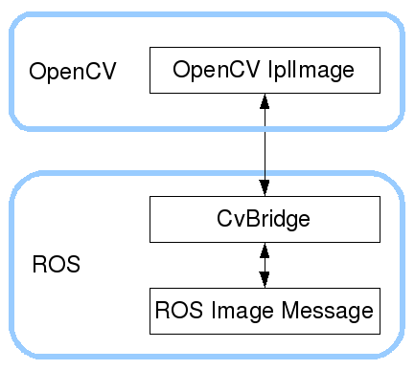

Figure 3-10 Conversion of Image data types from drone to QR code detector and decoder [2]

## **3.4 Integration of Functionalities**

Now that our group knows how to perform autonomous flight, detecting and decoding QR codes as well as displaying and storing the information on the drone, we wanted to integrate it all into a program that is easy to use. We decided to use a Graphical User Interface(GUI) that allows a user to start a stocktake, monitor the progress of the drone, and read the results of the stocktake.

#### **3.4.1 GUI Library**

To Create a GUI we have to choose a graphical user interface that we will be using for the project. We chose Dear ImGUI[4] as it allows us to choose our own backend for window creation and graphics backend.

Dear ImGui functions by outputting vertex buffers and command lists that can be easily rendered in an application. The number of draw calls and state changes required to render them is fairly small. Because Dear ImGui doesn't know or touch graphics state directly, its functions can be called from anywhere in a program’s code such as in the middle of a running algorithm. We use OpenGL to interpret the vertex buffers and commands output by Dear ImGui and communicate with the GPU. For creation and management of OpenGL windows, we have chosen GLFW. GLFW was chosen mainly for the simplicity of window creation, as well as the built-in keyboard and mouse input support which we will need for our GUI.

The CmakeLists for building the Dear ImGui libraryand setting its backend is

## Dependency libraries

set(OpenGL_GL_PREFERENCE GLVND)

find_package(OpenGL REQUIRED)

find_package(glfw3 REQUIRED)

## Add libraries

set(IMGUI_CORE_SRC

imgui/imgui.cpp

imgui/imgui_draw.cpp

imgui/imgui_widgets.cpp

imgui/imgui_tables.cpp

imgui/imgui_demo.cpp

)

set(IMGUI_BACKEND_SRC

imgui/backends/imgui_impl_glfw.cpp

imgui/backends/imgui_impl_opengl3.cpp

)

set(GL_LOADER_SRC

imgui/examples/libs/gl3w/GL/gl3w.c

)

set(IMPLOT_SRC

implot/implot.cpp

implot/implot_items.cpp

)

add_library(imcore ${IMGUI_CORE_SRC} ${IMGUI_BACKEND_SRC} ${GL_LOADER_SRC} ${IMPLOT_SRC})

target_link_libraries(imcore PUBLIC glfw OpenGL::GL ${GLFW3_LIBRARY} ${CMAKE_DL_LIBS})

target_compile_definitions(imcore PUBLIC "-DIMGUI_IMPL_OPENGL_LOADER_GL3W")

target_include_directories(imcore PUBLIC

$<BUILD_INTERFACE:${CMAKE_CURRENT_SOURCE_DIR}>

$<BUILD_INTERFACE:${CMAKE_CURRENT_SOURCE_DIR}/imgui>

$<BUILD_INTERFACE:${CMAKE_CURRENT_SOURCE_DIR}/imgui/backends>

$<BUILD_INTERFACE:${CMAKE_CURRENT_SOURCE_DIR}/imgui/examples/libs/gl3w>

$<INSTALL_INTERFACE:include>)

Unlike retained mode APIs such as Apple’s Cocoa, or DOM, ImGui as an immediate mode GUI, functions on a lower level, and each component is not stored, but recreated every cycle. It operates by writing an update function that draws the UI, passing in data and conditionally running callbacks for interactive elements like buttons. There is no model saved in memory, rather the structure of the UI is implied through the code path taken by the update function. The UI library uses this function to both draw the UI and handle user interactions.

Functioning at a lower level will grant us greater speeds and efficiency especially for smaller sized GUIs, which our project belongs to. Each render, though fast, still takes time, and any important functions that need to be executed at a high rate, or with minimal delay will exist in their own thread.

#### **3.4.2 GUI Code**

The GUI combines the functionalities of QR code Recognition and Autonomous flight, allowing a user to achieve autonomous flight while scanning for QR codes. The functionalities are accomplished by clicking buttons on the GUI, while all relevant information such as the drone’s camera stream, drone pose, drone status and decoded QR code information is displayed.

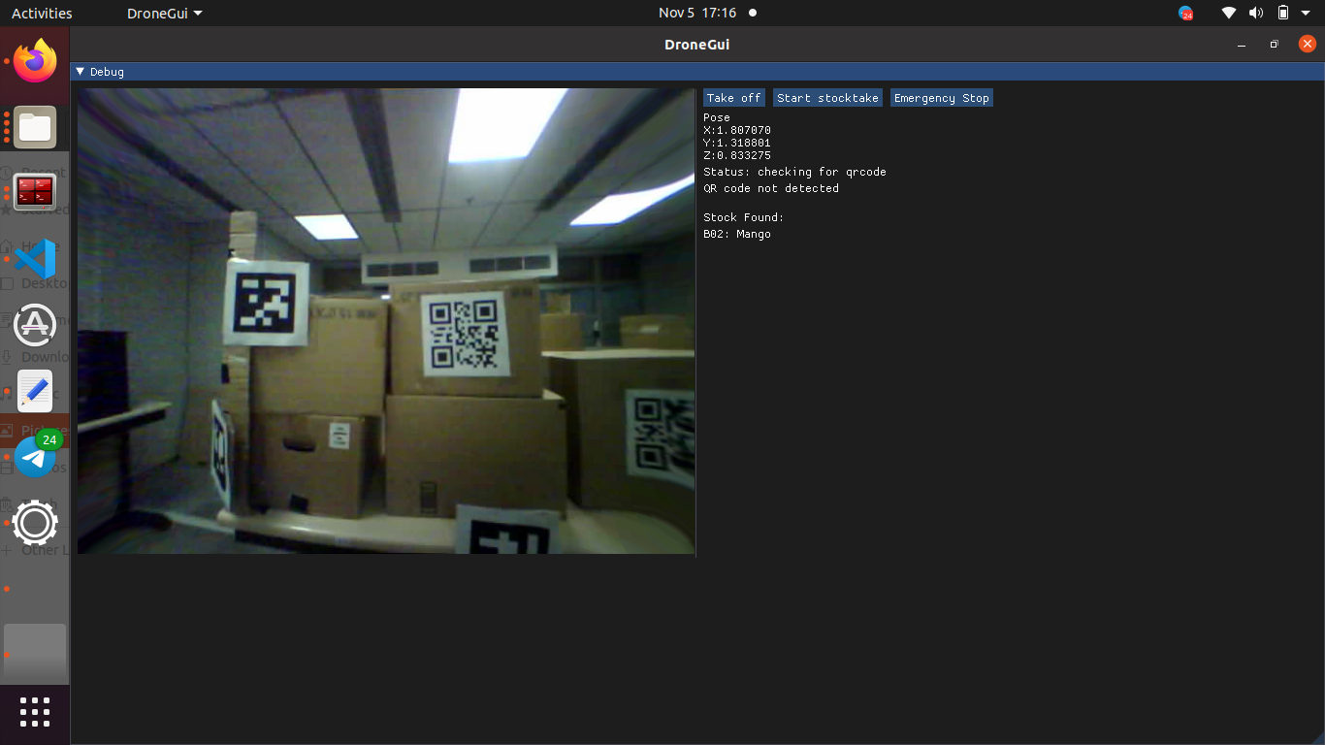

Figure 3-11: The GUI with camera stream and buttons

The button “Take off” initiates the drone to start flying, “Start stocktake” begins the process of a stocktake, where the drone flies to predesignated waypoints located where products would be stored. At each waypoint, if a QR code is detected, its data as well as position will be logged and displayed at the bottom.

“Emergency Stop” button is a safety feature that automatically shuts down drone flight. This is to prevent the drone from damaging people, products or itself in the case of any emergency or unforeseen drone behavior.

#### **3.4.3 Implementation Of Deliverables (Within GUI)**

##### **Implementation of Autonomous flight:**

As established in the Autonomous flight section we will use the ROS service “Go To” and the ROS topic “cmd_hover” established by the espdrone_driver package to direct the drone.

A separate thread is established for drone controls. One for calling the service, and another for publishing to the topic. This accomplishes two objectives. Firstly the sending commands to the drone is decoupled from the rendering of the GUI as rendering the video stream can possibly take some time depending on the contents to render as well as GPU, having the drone controls separated from the thread that renders and displays the GUI allows us to display the camera stream in its highest resolution without the rendering time affecting the rate of communication between the UI and the drone.

Secondly, this reduces the lag between the time when the “Go To” service has been successfully completed, and a message sent to the “cmd_Hover’ topic.

Both threads are a while loop with a boolean value “threadsrunning_” determining if the thread continues to loop. For thread safety, all values accessed and edited across different threads are of their equivalent atomic type such as atomic

//control variables

std::thread hover_thread_, waypoint_thread_;

std::atomic<bool> tohover_ , checkforqr_, stocktake_, threadsrunning_;

Each thread’s main functions are also nested within an “if” function.

When the Start Stocktake button is clicked:

if (ImGui::Button("Start stocktake")) {

stocktake_ = true;

}

The stocktake_ value is set to true. Setting this to true causes the functions with the waypoint thread to execute, and the thread calls the Go To service in a loop, starting from the first waypoint to the last. Between each service call, the loop pauses to allow the drone time to scan for QR codes and decode the data. During this wait, the cmd_Hover topic is used to make the drone Hover on the spot.

The logic of the waypoint thread is as follows:

1. Check the variable “threadsrunning_” to determine if the thread should continue to loop.
2. If the thread should continue to loop, check the variable “stocktake_” to see if the drone is conducting a stocktake
3. If the drone is conducting a stocktake, first, stop hovering by not publishing to “cmd_Hover”. This is done by setting the variable “tohover_” to false.
4. Call the service “Go To” to move to the next waypoint
5. After service has completed, resume hovering the drone by setting “tohover_” to false.

waypoint_thread_ = std::thread([this]() {

while(threadsrunning_){

if(stocktake_){

waypointcmd_ = waypointlist_[currentwaypoint_];

tohover_ = false;

if(waypointclient_.call(waypointcmd_)){

ROS_INFO("moving to point %d\n",currentwaypoint_);

waypointcmd_.request.duration.sleep();

}

tohover_ = true;

}

}

});

The logic of the hover thread is as follows

1. check the variable “threadsrunning_” to determine if thread should continue to loop.
2. If the thread should continue to loop, check the variable “to_hover” to see if the drone needs to be hovering at the moment
3. If the drone needs to be hovering, publish to “cmd_Hover” topic.

hover_thread_ = std::thread([this]() {

while(threadsrunning_){

if(tohover_){

if(!isflying_){

hovercmd_.zDistance = takeoff_.request.height;

}

else{

hovercmd_.zDistance = currentpose_.pose.position.z;

drone_hover_.publish(hovercmd_);

}

}

}

});

The emergency stop works by setting the variable checked by the drone control thread “threadsrunning_” to false. Once this variable has been set to false, no commands will be sent to the drone, and its flight will immediately end.

The setting of “threadsrunning_” to false is done through clicking the emergency stop button.

if (ImGui::Button("Emergency Stop")) {

threadsrunning_ = false

tohover_ = false;

stocktake_ = false;

estopclient_.call(estop_);

isflying_ = false;

emergencyclient_.call(std_srvs::SetBool);

}

As the drone controls are done on a separate thread to the GUI rendering, once the button has been clicked, the variable is set to false, and drone commands are immediately stopped, unaffected by any other lines of code that exists after the “emergency stop button” This keeps the lag between clicking the emergency stop and the drone stopping to a minimum, increasing safety.

##### **Implementation of QR Code detection and decoding**

As established in the QR detection and decoding section, we will detect and decode QR codes by subscribing to the “/espdrone/image_rect_color” topic, convert the message to a cv_prt, extract the OpenCV matrix and call the decoder functions.

// initialise ros subscriber and publisher

image_sub_ = nh_.subscribe<sensor_msgs::Image>("/espdrone/image_rect_color", 10, &DroneGui::QRCallback, this);

To display the image on the GUI, we need to convert the OpenCV matrix into a OpenGL texture, as we are using OpenGL as our graphical backend for ImGui. The callback function is fundamentally identical to the one described in QR Code detection and decoding, with an additional last 3 lines of code to convert the OpenCV matrix to an OpenGL texture.

void DroneGui::QRCallback(const sensor_msgs::Image::ConstPtr& msg){

cv_ptr_ = cv_bridge::toCvCopy(msg, sensor_msgs::image_encodings::BGR8);

image_ = cv_ptr_->image;

if(checkforqr_){

//std::cout<<"checking for qr"<<std::endl;

std::string qrdata = qrDecoder_.detectAndDecode(image_, bbox_, rectifiedImage_);

// std::cout<<qrdata.length()<<std::endl;

if(qrdata.length()>0){

// std::cout<<"data detected"<<std::endl;

if(last_data_.compare(qrdata)!=0){

//std::cout<<"data is new"<<std::endl;

found_qr_ = true;

last_data_ = qrdata;

if(stockfound_.size() == 0){

//std::cout<<"updating first entry"<<std::endl;

stockfound_.resize(1);

stockfound_[0] = last_data_;

}

else{

//std::cout<<"adding new entry"<<std::endl;

stockfound_.push_back(last_data_);

}

//std::cout << "Decoded Data : " << qrdata << std::endl;

}

else {

if(found_qr_){

found_qr_ = false;

//std::cout<<"No QR code detected"<<std::endl;

}

}

}

cv::cvtColor( image_, image_, cv::COLOR_BGR2RGBA );

glTexImage2D( GL_TEXTURE_2D, 0, GL_RGBA, image_.cols, image_.rows, 0, GL_RGBA, GL_UNSIGNED_BYTE, image_.data );

}

Once converted, this texture will be displayed on the GUI using the code

ImGui::Image( reinterpret_cast<void*>( static_cast<intptr_t>( texture ) ), ImVec2( image_.cols, image_.rows ) );

##### 

##### **Information Display**

The GUI will display the information obtained from the QR code to present a stocktake list.

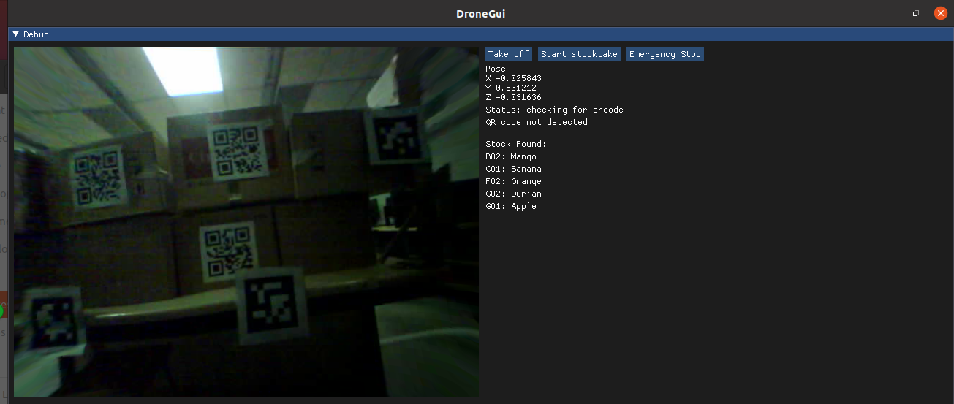

Figure 3-11: The stocktake list

This is accomplished by saving the information decoded into a vector

if(qrdata.length()>0){

// std::cout<<"data detected"<<std::endl;

if(last_data_.compare(qrdata)!=0){

//std::cout<<"data is new"<<std::endl;

found_qr_ = true;

last_data_ = qrdata;

if(stockfound_.size() == 0){

//std::cout<<"updating first entry"<<std::endl;

stockfound_.resize(1);

stockfound_[0] = last_data_;

}

else{

//std::cout<<"adding new entry"<<std::endl;

stockfound_.push_back(last_data_);}

}

The vector “stockfound_” will be used to display the information

ImGui::Text(" \nStock Found:");

if(stockfound_.size()>0)

for(int i =0; i<stockfound_.size(); i++){

if(stockfound_[i].compare("Mango")==0)

ImGui::Text("B02: %s", stockfound_[i].c_str());

else if(stockfound_[i].compare("Banana")==0)

ImGui::Text("C01: %s", stockfound_[i].c_str());

else if(stockfound_[i].compare("Orange")==0)

ImGui::Text("F02: Orange");

else if(stockfound_[i].compare("Durian")==0)

ImGui::Text("G02: Durian");

else if(stockfound_[i].compare("Apple")==0)

ImGui::Text("G01: Apple");

}

else {

ImGui::Text("No Stock Detected Yet");

}

## **3.5 Creating simulated warehouse environment**

In the beginning, the project helpers had set up aruco markers for us in the lab for us to test out and assess whether our drone was functioning properly. The marker size for those markers was 0.32. However, to create a simulated environment of a warehouse, we had to plan and set up our own area, along with the appropriate aruco markers to create the visualisation of the area for the drone. Thus, we had to consider scaling down the size of the markers to fit them in a warehouse context.

The accuracy of using ArUco Markers to determine a robot’s position and orientation is affected by the size of the marker and the speed at which the robot is moving relative to the marker. Reducing the size of the marker therefore has its limits and the accuracy of determining the drone’s position while it is moving decreases if the ArUco markers are too small. In the end, the aruco size of 0.152 was used as it was able to fit in the environment while still being able to be detected by the drone at a reasonable distance and relative velocity, as compared to other sizes.

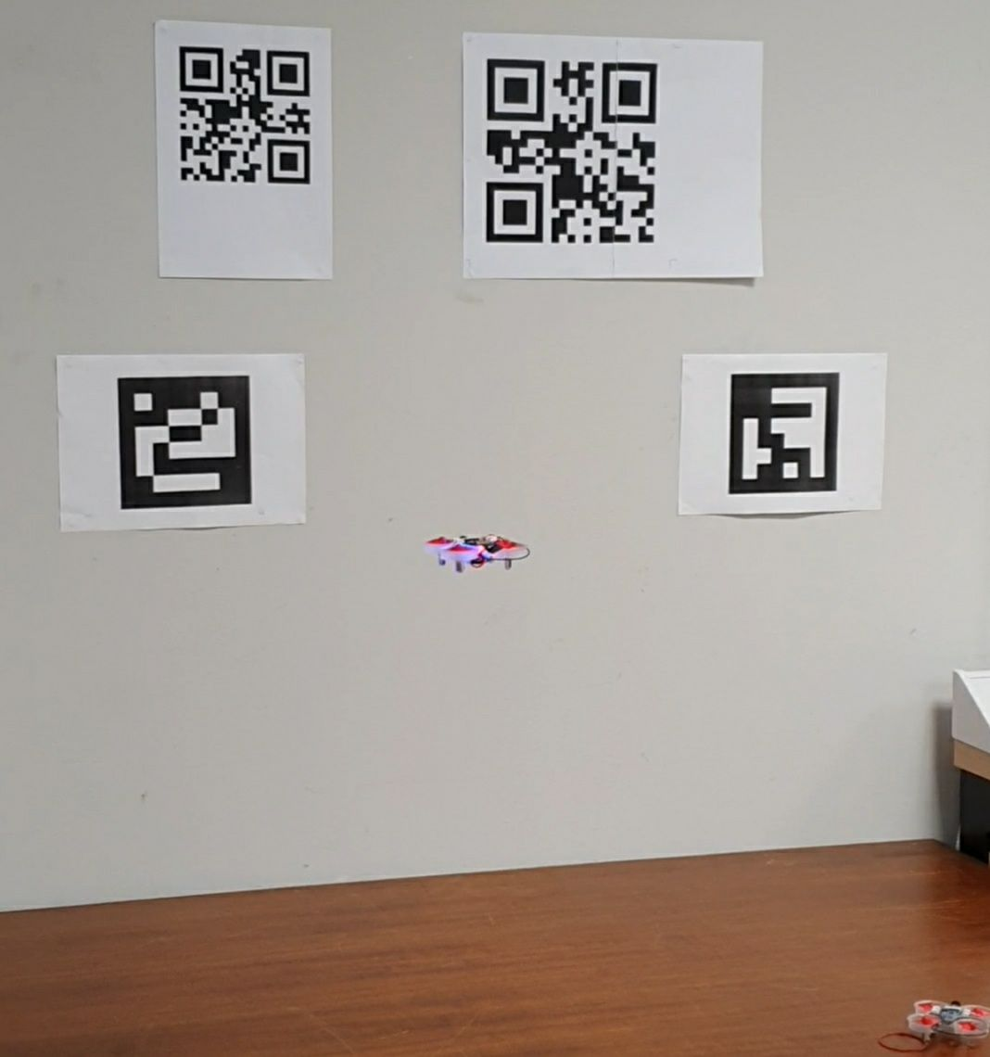

Figure 3-12: Testing appropriate size for ArUco markers

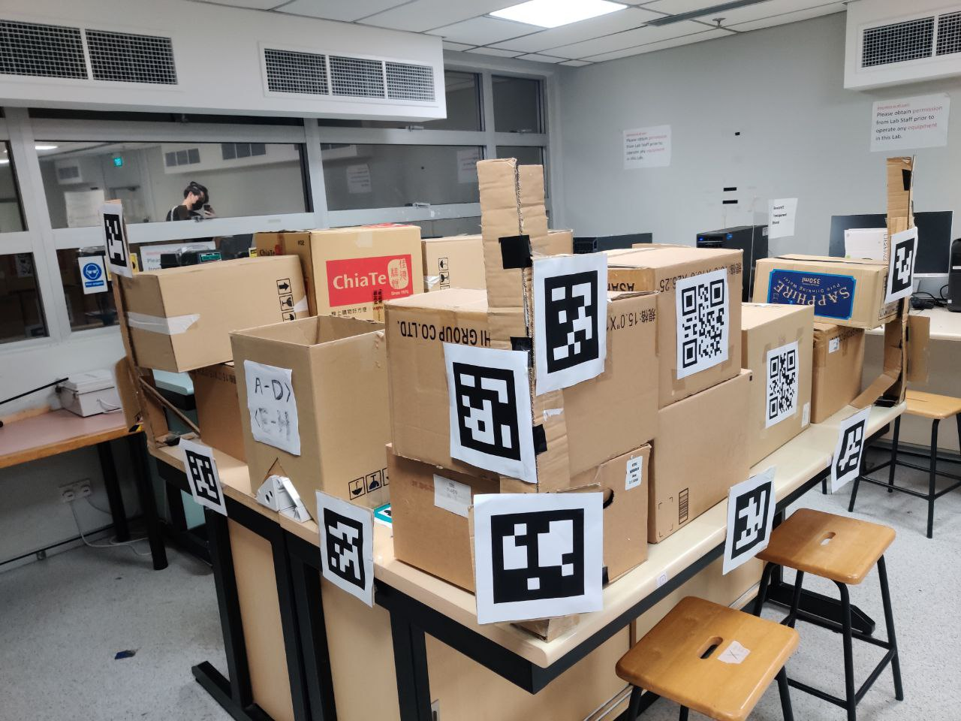

Figure 3-13: Setting up the ‘warehouse’ environment

The physical environment was then set up to simulate a warehouse with 2 rows of boxes labeled by QR-Codes and the ArUco markers on the corners and sides of the shelves. During the integration of the aruco markers, we faced the problem of the drone not being consistent with detection of the aruco markers. This was due to the limitation of the drone always needing at least 2 aruco markers being detected to calculate its pose and remain in flight.

Thus the number of markers used and the spacing in between them was extensively tested out until the drone was able to stay in flight because it was able to detect two aruco markers at the same time.

Another problem that we foresaw was that it would lose vision of the aruco markers while turning around the corner. We adapted to this problem by placing aruco markers in each of the corners at 45°, as well as keeping the changes in movement to a minimum while the drone was making a turn. This allowed for smoother turning and fewer errors when the drone was navigating through the environment.

#### 

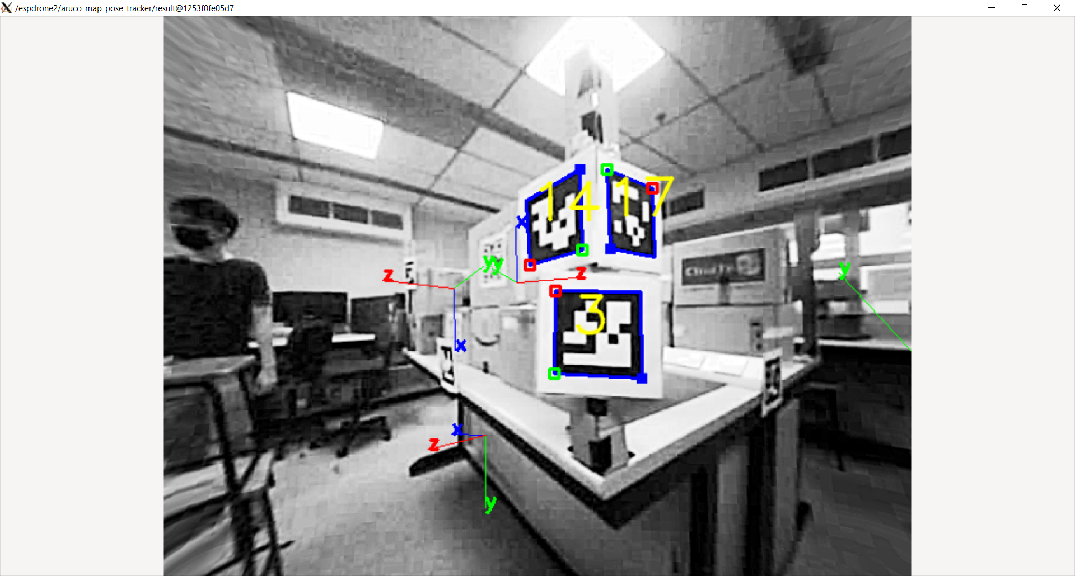

Figure 3-14: Aruco marker placed on corner at 45°

## 

## 

## **3.6 Changes To Scope**

Our initial idea was a drone that could move between waypoints in an area, which can then be used as a guide to bring people to places, or along a tour. It involved people using visual information to tell the drone where they wanted to go. This information can be understood by the drone either through a text reader, or even QR codes. Once the drone registers the destination requested it will begin its flight path, guiding people to the destination.

However, during a discussion with our supervisor he helped us realise that the small weight of the drone means it is easily affected by even gentle winds. This limited it to only indoor navigation, which greatly hampered its usefulness. As such we shifted to something similar yet not as affected by the drone’s small size, which was warehouse stocktaking. As warehouses are indoor closed areas to begin with, the small weight of the drone was not a limiting factor, and the drone is a much more suitable solution for such a problem.

Similar to both ideas were the fundamental concepts of the drone, understanding visual information and conducting autonomous flights. Therefore we shifted our drone’s information reading from registering a desired destination to registering a product in a warehouse.

With this change in objective, the drone’s interaction with the users has also changed. When using the drone as a guide the user provides the drone with visual information of its destination that it can understand. However, using the drone to conduct a stocktake now requires us to output visual information for the user to understand such as the results of the stocktake. Thus, we decided to build a GUI that is able to show this info in a neat manner, along with some inputs.

# **4. Weekly Schedule**

Our project took place over the span of academic weeks 1-13 from August to November, and within this period, the project went through six phases. The chronological order can be observed on the Gantt Chart below:

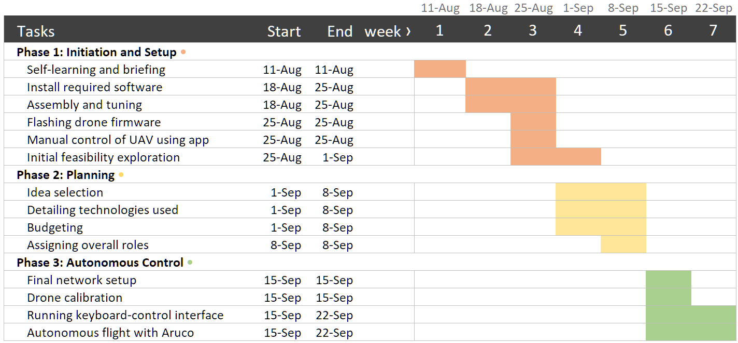

Fig 4-1: Gantt Chart for Phase 1-3

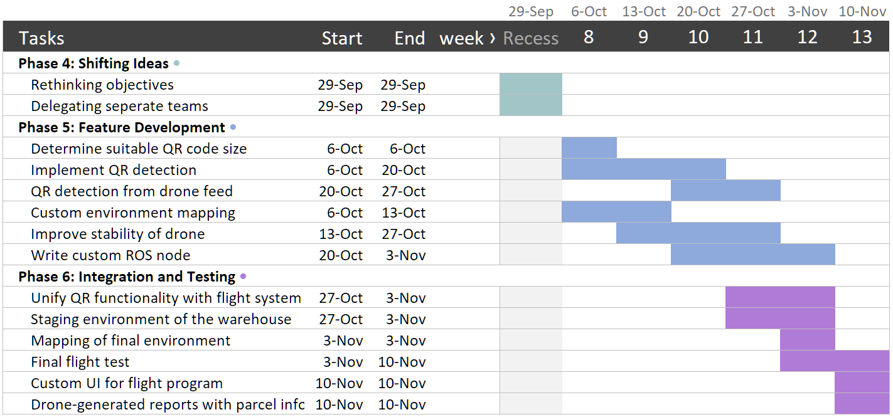

Fig 4-2: Gantt Chart for Phase 4-6

A brief explanation of the various phases is as follows:

### **Phase 1 • Initiation and Setup** (Week 1-4)

During these first few weeks, we did the groundwork to start developing our project, such as assembling the drone and installing the required software. We first flew the drone using a remote-control app. Based on how the drone operated, we came up with an initial list of feasible ideas we could work on.

### **Phase 2 • Planning** (Week 4-5)

Here, we started charting out our ideas for exploration, where we initially aimed to build a drone that acted as a navigator assistant. We decided to use Aruco mapping, along with OpenCV imaging to build functionality. We also budgeted for the parts that we intended to add and assigned overall roles, splitting into teams to work on object avoidance and QR detection.

### **Phase 3 • Autonomous Control (**Week 6-7)

We finalised setting up the network config for two drones to operate and did our custom mapping for a new environment. Using a prebuilt GUI, we successfully instructed the drone to fly between our custom waypoints. This period is also where we were continually working to improve its stability during flight, as it would frequently crash.

### **Phase 4 • Shifting Ideas** (Recess Week)

We decided to change our project scope from a ‘guide’ drone to a stocktaking drone, because of certain feasibility issues (discussed earlier in 3.6). We then finalised our deliverables into the ones we had and split into two teams. A team doing QR code recognition and the other doing Aruco Markers.

### **Phase 5 • Feature Development** (Week 8-12)

The team working on QR recognition determined a suitable QR marker size for the distance the drone was located, implemented QR code detection using test images and OpenCV, and eventually merged it to the Aruco system.

Meanwhile, the Aruco team continued to test out a custom set of markers. They wrote a custom program that communicated with ROS services to set custom waypoints. The team also continued to fine-tune the flight stability through repeated testing.

### **Phase 6 • Integration and Testing** (Week 11-13)

*\*Lastly, after ensuring the two functions were merged, we built a simulated warehouse environment and set up a test flight which was successful. A user GUI with the combined functionality was added, which could take user commands, view the camera feed and also output names of the recognized stocks.

# **5. Project Costs**

Project Purchases:

| Phase | Purchases | Cost | Purpose |
| --- | --- | --- | --- |
| Initiating Phase | - | - | - |
| Planning Phase | - | - | - |
| Execution Phase  (phases 3-5 from previous section) | 400mAh Battery | $8.04 + $1 Shipping | To allow the drone to have a longer flight time |
| Closing Phase | - | - | - |
| Project Total Costs | - | $9.04 | - |

In this project, the necessary materials such as the ESP 32 board, drone body, and drone motors were provided for us. The only purchase was for a 400mAh battery that can extend the drone’s flight time, improving flight time to 10+ minutes over the original 5 minutes with the original battery. This greatly improves the reliability of the demonstration where we pilot the drone around a simulated warehouse environment.

# **6. Outcome / Expected Outcomes**

The goal of implementing the QR-code scanner into the drone was completed and was able to traverse the warehouse-like environment in the test run. Thus, the drone has been proven to be capable of solving the problem of warehouse stock taking and the original project goal of building an autonomous flying drone that is capable of solving real world problems was met.

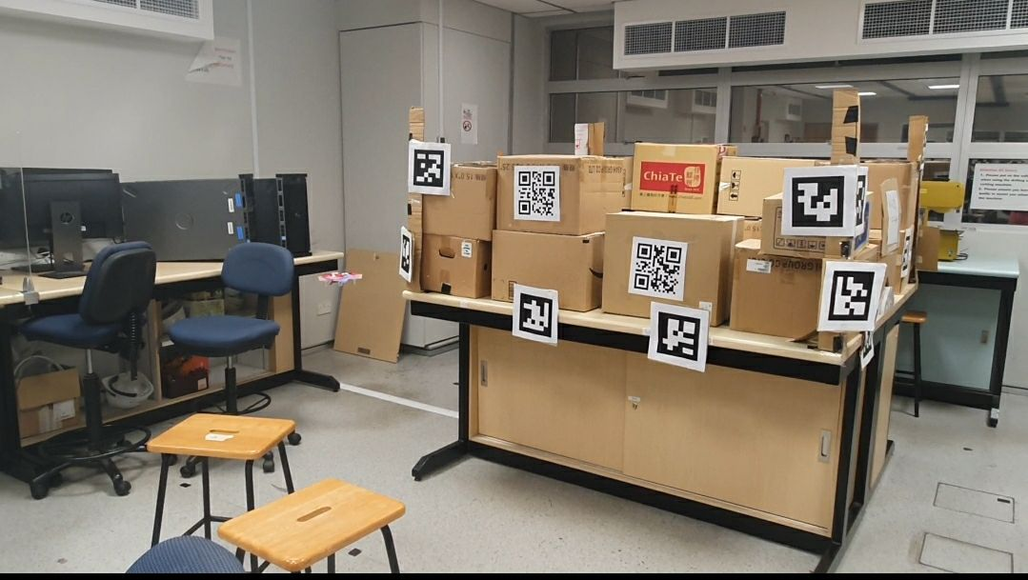



Figure 6-1: Drone successfully in flight with image processing



Figure 6-2: GUI outputting the label (Mango) for the box

Many skill sets were taken away from this project such as soldering, creative thinking and troubleshooting. Furthermore, we got exposed to many different platforms and coding languages such as Microsoft Visual Studio Code, ROS, C++ and Python. The experiences gained are invaluable to our future endeavors in the engineering industry.

# **7. Reflection**

## **7.1 Engineering Knowledge/ Problem Analysis**

There are some known limitations for the drone. If the QR code that is used on the stock boxes is too small or damaged the drone might not be able to read the QR codes. To correct this issue the possible solution is to improve the camera to a higher-resolution one. However, due to the size and capability of the drone, the resolution cannot be adjusted any higher as a higher resolution would result in a slower frame rate for the camera to drone transmission.

Another limitation of this project would be giving the drone the ability to fly on its own without the use of Aruco markers. In order for the drone to fly by itself, we have come up with a solution of implementing infrared sensors on the drone to detect the distances of x-y-z. However, this was limited by how much weight and process the drone can withstand in order to allow it to fly autonomously. The drone has only a 10cm x 10cm dimension and has limited battery life. Without any additional functions, the drone can only fly for a period of -15mins. To add a capable infrared sensor that can detect far distances (more than 50cm) we would need the drone to be able to withstand the extra load and the extra process. This would compromise the flight of the drone in the end. Therefore, due to the limitations of the drone we are not able to implement this feature onto the drone.

We also planned for a mapping feature for the drone, for the drone to be able to fly autonomously around the room and be able to map out its surroundings. However, as the drone is unable to detect its surroundings without the help of aruco markers we are unable to implement this feature.

## **7.2 Design / Development of Solutions**

**Problem:** Warehouses have to use manual labour to manually stock-take on stocks in the warehouse, stocks placed in high places have to require machinery to stocktake.

**Solution:** Using an autonomous flight drone to stock-take to eliminate the need for manual labour, and use a QR code scanner to identify each stock box.

In this project, we learned to use VS Code to write our programs and use multiple libraries and platforms to assist us in achieving our desired results. Initially, we had to familiarise ourselves with the whole operation of the drone. With the guidance of Nelsen and Andrian, we are able to understand how the drone operates. Using ROS, the drone is able to communicate with the user and send real time feedback to the user. We had to write a program to allow the drone to fly autonomously through different points using Aruco markers. Whilst flying the drone would be able to detect QR codes scanned along the way and decipher the QR codes too. The information on the deciphered QR codes will then be fed back to the user and recorded down in a CSV file.

## **7.3 Individual and Team Work**

To facilitate the project and to ensure that the workload is properly distributed we decided to split the group of 5 into 2 main groups, the hardware group (Alex, Zhen Yong) and the software group (See-To, Pin Che, Ivan). The hardware group focuses on the hardware aspect of the project, understanding the capabilities of the drone and the required functions that we might need in order to allow the drone to achieve its tasks. The software group focuses on the software needed to allow the drone to achieve its tasks, such as autonomous flight programming, QR code detection and recognition, and the necessary codes required to allow the drone to function properly

## 

## **7.4 Future Recommendations**

In this project, we are constantly faced with limitations as the drone is not capable of supporting many additional functions. Below are some future recommendations we have for the drone’s use and development.

1. **Increase the size of the drone**. This would allow us to add a more advanced PCB with more computing power as well as stronger motors. By strengthening the motors the drone would have a higher weight limit and we can implement more functions to the drone such as LIDAR sensors and infrared sensors.
2. **Implement autonomous flight of the drone without the use of external markers**. Currently, we are using Aruco markers in order for the drone to be able to estimate its current pose position for autonomous flight. It would be ideal if the drone is able to estimate its own flight pose position as that way the drone would be able to achieve autonomous flight in any environment.
3. **Fly the drone in a controlled environment with no moving objects.** Since we were not able to implement obstacle avoidance, the drone cannot avoid crashing into moving obstacles, like forklifts or workers. This means that the flight of the drone has to be within a restricted space with minimal moving objects, to avoid clashing with its flight path.
4. **Expansion of capabilities**. In this project, many features that require no external components could potentially be added to the drone. These include face recognition, detailed item detection, GPS positioning, etc. We did not implement such features into the drone in order to focus on our core problem. However, such expansion is definitely possible.

## 

## **7.5 Methodologies Applied**

**Elaborate SMART Approach**

|  |  |  |  |  |  |  |  |  |
| --- | --- | --- | --- | --- | --- | --- | --- | --- |
|  |  | **SMART questions** | | | **SMART answers** | | | |
| **S p e c i f i c** | | **Q1:** *What is the goal?*  **Q2:** *What are the details of the goal?*  **Q3:** *What do I want to accomplish with it?*  **Q4:** *Who is involved?*  **Q5:** *Where is it going to happen?*  **Q6:** *What resources are available?* | | | **A1: To solve the problem of using manual labour to stock-take, and stock-taking at high places**  **A2: To program a drone to fly autonomously to be able to stock-take instead of using people**  **A3: Eliminate the need for human labour for stock-taking in warehouse**  **A4: See-To, PinChe, Ivan, Alex, Zhenyong, and Prof Chong**  **A5: The project will take place in NTU and the situation will be situated in a large warehouse**  **A6: Available resources will be a fully flight capable drone given to us by the school. Including microprocessors, motors, drone body, etc.** | | | |
|
|
|
|
| **M e a s u r a b l e** | | **Q1:** *How will I measure progress?*  **Q2:** *Do I have the necessary tools to measure your progress?*  **Q3:** *How will I know the goal has been accomplished?* | | | **A1: We will be using a gantt chart to record our progress and weekly logs to record our work**  **A2: Yes, by using various planning tools such as gantt chart**  **A3: The desired result will be compared with the final result in order for us to determine whether or not the project is successful** | | | |
|
|
|
|
| **A t t a i n a b l e** | | **Q1:** Do I have the financial capacity to carry out my goal?  **Q2:** Do I have the skills and willpower to carry out my goal?  **Q3:** Will I have access to help when needed?  **Q4:** Do I have all the necessary resources?  **Q5:** Do I have the time to carry out the goal? | | | **A1: Allocated budget of 350$, based on technical knowledge budget is deemed sufficient.**  **A2: The team has taken past projects and has various programming languages such as C++ and Python. With guidance from Nelsen and Andrian as well.**  **A3: Professor Chong and Student guides are available to us.**  **A4: Necessary resources are given to us. Additional resources will have to be evaluated throughout the project**  **A5: Given 13 weeks to finish the project, time constraint is a factor in this project but given our tasks we have deemed that we have enough time to complete at least the basic function of our mission, which is to have the drone fly autonomously with QR code detecting capabilities** | | | |
|
|
|
|
| **R e l e v a n t** | | **Q1:** Why is this goal important?  **Q2:** Is this goal worth my time?  **Q3:** Is this the right time for it? | | | **A1: This goal will reduce workplace accidents and effort as manual labour is no longer required to stock-take at the warehouse.**  **A2: Yes as we believe that it will greatly benefit the logistic sector in our society**  **A3: Yes as this idea has not been implemented in Singapore logistics yet** | | | |
|
|
|
|
| **T i m e - b o u n d** | | **Q1:** When will I achieve the goal?  **Q2:** When will I carry out the activities that will bring me to my goal?  **Q3:** When can I expect the first outcomes? | | | **A1: Timeline is to complete the project within 13 weeks**  **A2: A planned project charter will allow us to keep track of our activities each week and serve as a reminder on deadlines**  **A3: First outcome is expected to be seen after recess week (week 8), first full autonomous flight of drone** | | | |
|
|
|
|

**RACI Chart**

| RACI CHART |  |  |  |  |  |
| --- | --- | --- | --- | --- | --- |
| Activity | Junwei | Ivan | Zhen Yong | Alex | Pin Che |
| Define Requirement | R | A | C | I | I |
| Design Model | I | R | A | C | C |
| Build Prototype | C | I | R | R | A |
| Conduct System Testing | A | C | I | A | R |

# **8. Individual Contributions**

|  | **Name** | **Project contributions** | **Report Contribution** |
| --- | --- | --- | --- |
| **1** | **See-To Junwei** | **- Group Leader.**  **- Coordinate with the supervisor with regards to the project**  **- Assisted in writing python algorithms for QR code recognition and feedback.**  **- Troubleshooted for errors**  **- Helped with report and slides** | **Wrote Purpose, Project Summary**  **Wrote Reflection Summary (RACI chart, SMART chart)**  **Contributed to the Scope (QR Code Detection)** |
| **2** | **Ivan** | **- Treasurer, tracked project cost**  **- Assist with Aruco custom maps and flight testing**  **- Planning and setting up simulated warehouse environment** | **Wrote Weekly Schedule and improved Purpose + Project Summary**  **Grammar and format fixes for overall Report** |
| **3** | **Pin Che** | **- Software programmer**  **- Wrote GUI programming.**  **- Tested drone’s autonomous flight capabilities** | **Structured and greatly contributed to the Scope.** |
| **4** | **Alex** | * **Tested aruco markers for autonomous flight** * **Assisted with environment mapping and autonomous flight testing** * **Assisted with planning and setting up simulated warehouse environment** * **Troubleshooted for errors** | **Contributed to the Scope**  **Checked for grammar and elaboration of overall content** |
| **5** | **Zhen Yong** | * **Planned and Set Up Simulated Warehouse Environment** * **Assisted with camera calibration and environment mapping for autonomous flight testing** | **Contributed to the Scope**  **Grammar Fixes and Elaboration of Content** |

# **9. References**

[1] - Aruco Markers

<https://www.uco.es/investiga/grupos/ava/node/1>

[2] - QR Code Recognition with OpenCv

[QR Code Scanner using OpenCV 4 (C++ & Python)](https://learnopencv.com/opencv-qr-code-scanner-c-and-python/)

[3] - ROS images to OpenCv

<http://wiki.ros.org/cv_bridge/Tutorials/ConvertingBetweenROSImagesAndOpenCVImagesPython>

[4] - <https://github.com/ocornut/imgui.git>